**BONUS IOT Activity:**

Copy and paste the CheerLights code into a new Arduino Sketch.

[CheerLights](https://github.com/Switchback42/YHA-ESP8266-Sketches/blob/master/YHA_cheerlights_NODE.ino)

In the main menu of Arduino, click on the **Sketch** dropdown menu

→Include Libraries

→Manage Library

Once you’re in In the Library Manager, use the search bar to find and install the Adafruit NeoPixel and ThingSpeak libraries.

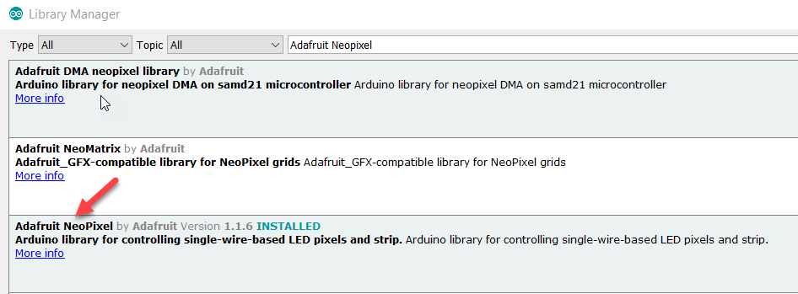

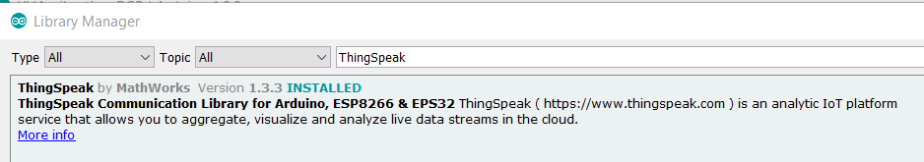

Restart Arduino.

Hook your PLC up to the Neopixel. The left pin goes to ground. The middle pin (your data pin) goes to D2. The right pin goes to 3V.

Watch what happens when people on Twitter tell @Cheerlights to turn the NeoPixel a specific color.

